Deploy the Application Tier (Backend API)
Deploy the Backend API.
Step 1: Connect to the Private EC2 Instance
Since the EC2 instances reside in Private Application Subnets, cannot connect to them directly via public SSH. must bridge through a Bastion Host or utilize AWS Systems Manager (SSM) Session Manager. I am using Jump server.
Step 2: Install Python 3 and Virtual Environment Tools
Update your package repository manager and install Python 3, its package manager (pip), and venv.
sudo apt update
Install pip:
sudo apt install python3-pip -y
Install Python virtual environment support:
sudo apt update
sudo apt install python3-venv python3-full -y
Create a virtual environment:
python3 -m venv venv
Activate the virtual environment:
source venv/bin/activate
Install the required Python packages:
pip install Flask PyMySQL gunicorn
Install the MySQL client to connect to the Amazon RDS database:
sudo apt install default-mysql-client -y
mysql –version

Step 3: Create the Flask Application
sudo nano app.py (Add your Flask application code to this file.)
Start the application in the background:
python3 app.py &
Test the application locally:
curl localhost:5000
Output
{"status": "Flask is running"}
Output Virtual environment
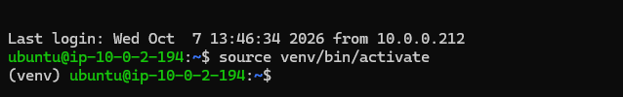
Output of background running
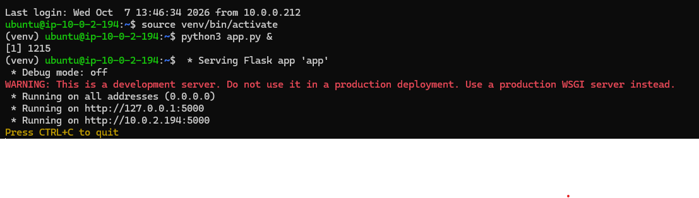
Output of flask running
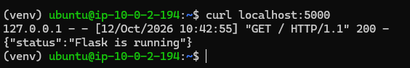
Also need to configure Database Credentials in app.py file
DB_CONFIG = {
'host': 'RDS-ENDPOINT',
'user': 'admin',
'password': ' Sraboniadak!',
'db': 'feedbackdb',
'cursorclass': pymysql.cursors.DictCursor

